Ulric Aird

Networking 2

Graded Assignment 1

For this assignment, we had 3 servers, 4 switches and 20 PCs all connected to each other; as seen from the screenshots below.

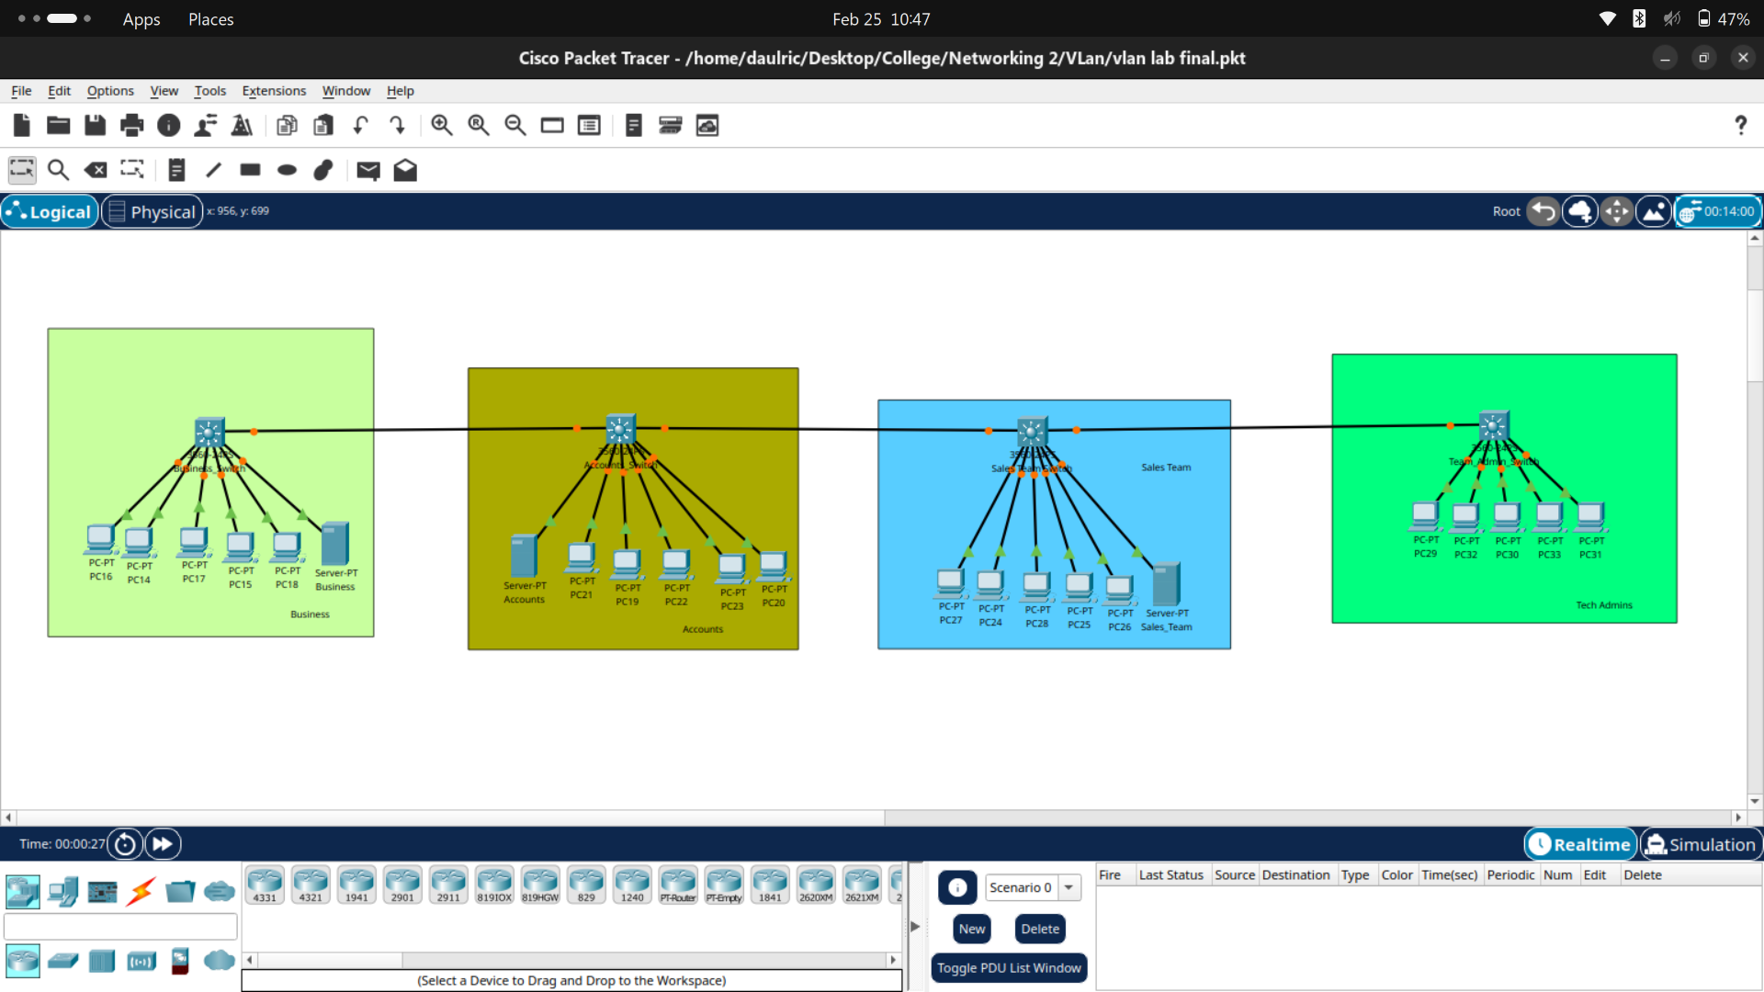

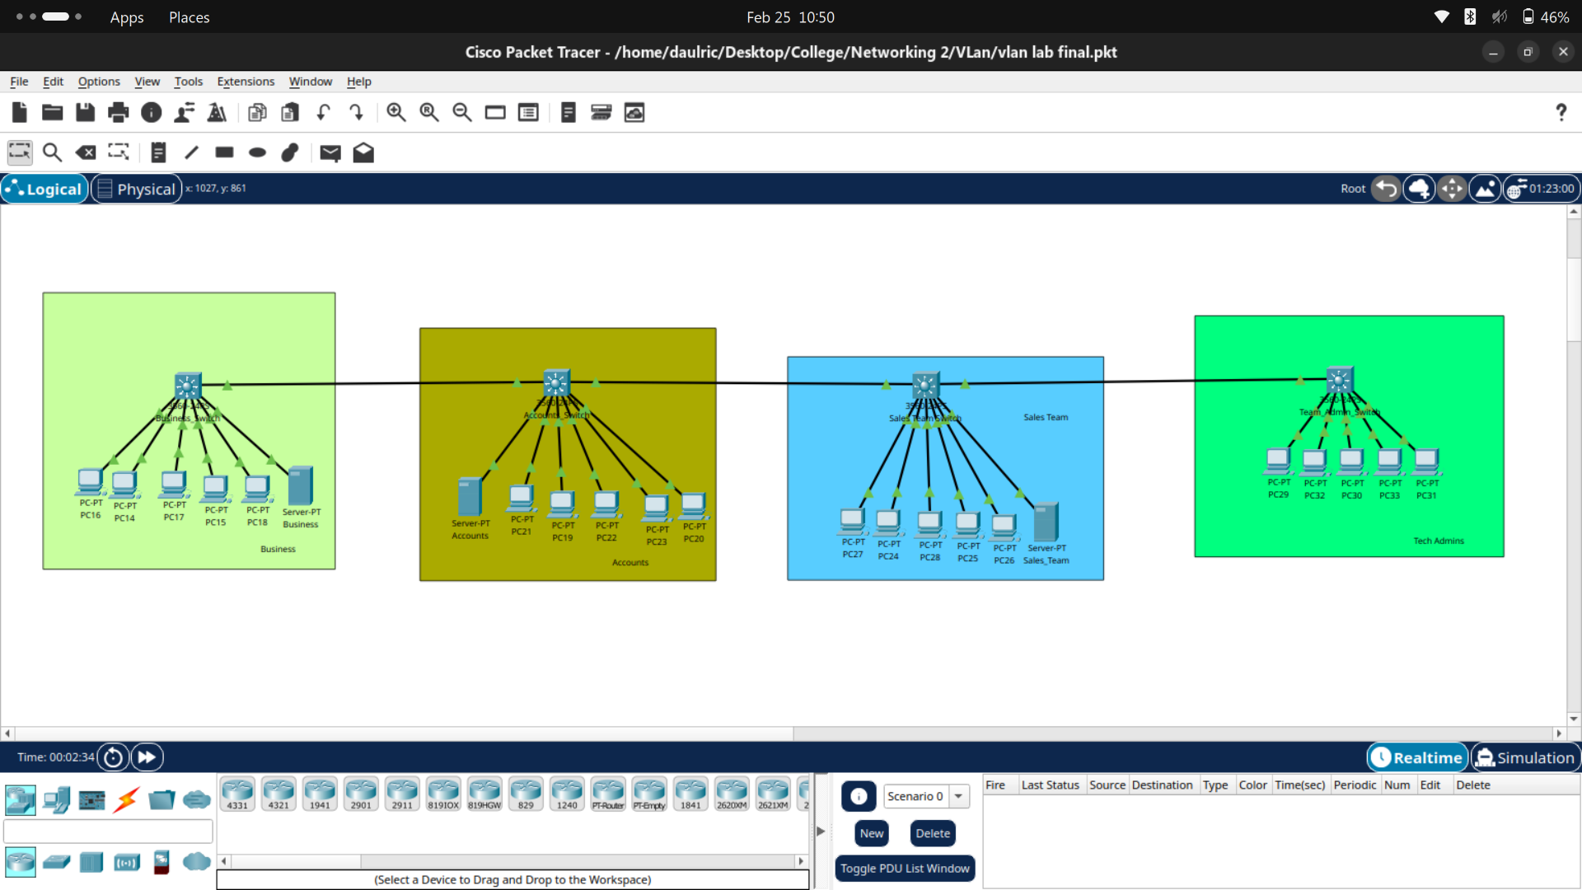

There were 4 groups of networks and they were interconnected. These groups where Business, Accounts, Sales Team and Tech Admins and each groups have individuals VLANs assigned to them.

PCs on the same VLAN can interact with each other but PCs on different VLAN cannot. However they can interact with different switches on different vlans. On the other hand, all the configurations was set up properly.